

SIMATS ENGINEERING

Saveetha Institute of Medical and Technical Sciences
Chennai- 602105

Student Name: KONGARA SAI Reg. No.:192365025
Course Code: CSA1515 Slot: B
Course Name: CLOUD COMPUTING AND BIG DATA ANALYTICS
Course Faculty: SMAPATH KUMAR K
Project Title: Design and Implementation of a Secure Cloud-Based File Storage and Collaboration Application (CloudVault)
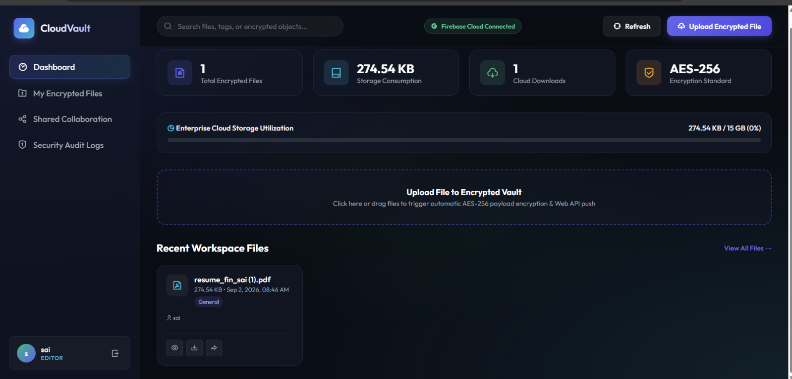 APPLICATION
Project Description: CloudVault is a secure cloud-based file storage and collaboration application developed using Google Firebase Cloud Services.
It uses Firebase Authentication to provide secure user login and identity management.
Files are encrypted on the client side using AES-256-GCM before being uploaded to cloud storage.
Cloud Firestore stores file metadata, versions, comments, sharing permissions, and security audit logs.
The system supports role-based access control with View, Download, and Edit permissions.
It also provides real-time document collaboration, version history, file sharing, and activity tracking.
CloudVault combines cloud scalability, data confidentiality, integrity verification, and a modern responsive interface into one secure platform.

Student Signature Guide Signature

